INDUSTRIAL ETHERNET SWITCH
Hardware Requirement Specification
Rev-B

29-Apr-2013

Ownership Disclaimer
This document contains proprietary and confidential material that is the sole property of Compressor Controls Corporation. The information contained herein is intended for internal use by Compressor Controls Corporation employees and is not intended for distribution outside of the company. As an unpublished work of trade secrets, the recipient shall keep this document confidential. Any re-use, copying, or distribution, either in whole or in part, of this material without the express written consent of Compressor Controls Corporation is strictly forbidden.
Copyright © 2013 by Compressor Controls Corporation. All rights reserved.

Revision History

Rev. | Date | Revised By | Description
B | 29-Apr-13 | Muthuvelu.D | Initial release

Approvals

Approved by: Date: _______________
Approved by: Date: _______________
Approved by: Date: _______________
Approved by: Date: _______________
Approved by: Date: _______________

TABLE OF CONTENTS

1 Introduction 5
1.1 Purpose 5
1.2 Audience 5
1.3 Scope 5
1.4 Acronyms 5
1.5 References 5
2 General Description 6
2.1 System Overview 6
2.2 Product Functions 7
2.3 Block Diagram 8
3 Electrical Requirements 8
3.1 EtherCAT Slave Controller 8
3.2 EtherCAT Configuration PROM 8
3.3 APP Backplane Interface 9
3.4 IOP Backplane Interface 9
3.5 10/100 Ethernet Port 9
3.6 Hot swap and load sharing 9
3.7 Supervisory/ Reset Circuit 9
3.8 Microcontroller 9
3.9 Power Supply 9
3.10 Debug/ Diagnostic 9
3.11 ESD Protection 10
4 Specific Requirements 11
4.1 Functional Requirements 11
4.2 Schematic 11
4.3 Layout 11
4.4 Environmental Specification 11
5 Not in Scope 12
6 Deliverables 12
7 Testing Requirement 12
8 Appendix 13
8.1 Frame Processing Unit: 13

Introduction

Purpose
The purpose of this document is to capture the hardware requirements for IES card (Industrial Ethernet Switch card) which is used as EtherCAT processing unit on New Generation Platform (NGP) control system.

Audience
This document is meant to be used by the project team members as the basis and controlling document for the design and development of IES card.

Scope
IES Card is a BECKHOFF EtherCAT Slave Controller based design which will be used as EtherCAT communication unit for New Generation Platform control system. This document defines the product requirements to which hardware has to be designed and manufactured. This document also covers system level requirements applicable to IES card. This document doesn’t cover the firmware/ software related requirements.

Acronyms
Acronym | Definition
IES | Industrial Ethernet Switch
ESC | EtherCAT Slave Controller
NGP | Next Generation Platform
APP | Application Processor Board
IOP | IO Board Analog/Digital
PCC | Power Conversion Card

References
[1] Detailed Functional Specification for NGP Hardware, Part 1, Rev-3
[2] System Study for New Generation Platform Electronics and Bring-up, Rev-1
[3] EtherCAT_ET1100_Datasheet_all_v1i8.pdf from BECKHOFF
[4] EtherCAT_ Communication document

General Description

System Overview
New Generation Platform (NGP) is a fully redundant, duplex, highly available, fault tolerant control system intended to handle a number of digital, analog and frequency IOs in industrial applications. Below is the system block diagram of NGP.

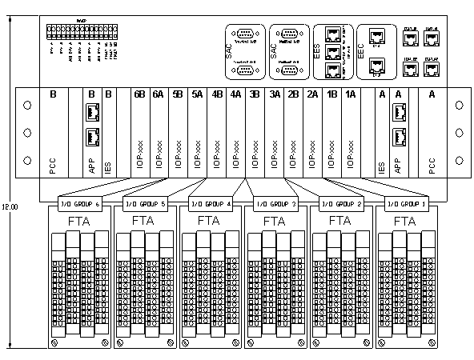Here is the list of different electrical components in the system and their brief description.

APP
This is the main processing unit in the system. This runs the main application and does monitoring and control of the overall system. There will be a maximum of 2 such cards in an NGP system.

IOP (Digital and Analog)
These are the processors cards which handle digital, analog and frequency IOs. There will be a maximum of 12 such cards in an NGP system.

IES
This is the EtherCAT switch card used to interface between different APP and IOP modules. There will be a maximum of 2 such cards in an NGP system

PCC
This is power conversion card. The input power (redundant 24VDC) to the system first comes to this card. This card does the ORing, filtering, protection and other voltage conversion. There will be a maximum of 2 such cards in an NGP system

FTA (Digital and Analog)
These are the field terminal cards where all the field loads are connected to. These are electrically interfaced to IOP cards. The number of FTA in an NGP system is same as the number of IOP card

CAC
These are the set of communication (Ethernet, RS-485) cards used for interface to the external devices

Backplane
All the above mentioned boards plug in backplane and communicate to each other over it.

Product Functions
IES is the EtherCAT Communication unit in the system. BECKHOFF ET100 EtherCAT Slave Controller to be used for switch functionality. It implements EtherCAT protocol for communication between different boards. It features one MII interface to communicate to APP board and 13 EBUS interfaces to communicate to all IOP boards via Backplane. It also implements 10/100 Ethernet port for communication to external device.

Block Diagram

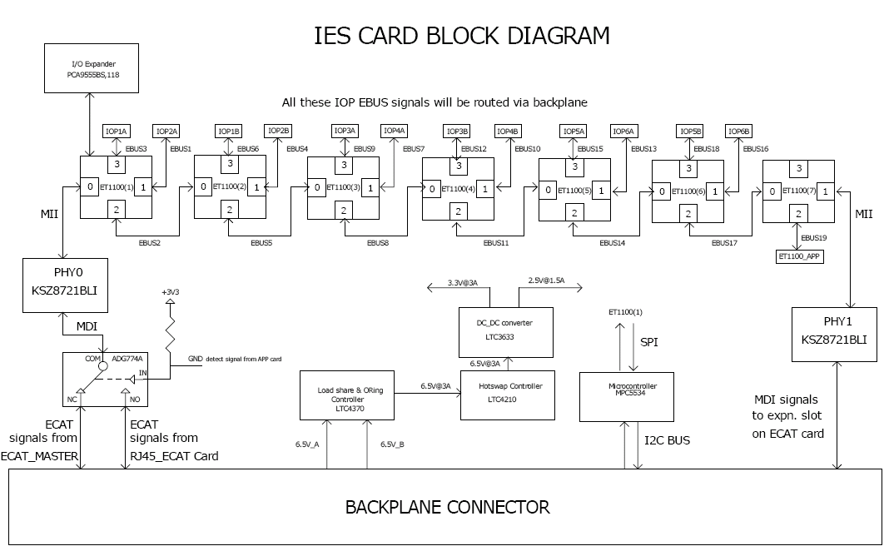
The diagram above shows how the APP and IOP boards are connected to EtherCAT Slave Controller ports.

Electrical Requirements

EtherCAT Slave Controller
    - BECKHOFF ET1100 EtherCAT Slave Controller shall be used for switch functionality
    - Transmission speed for EtherCAT is 100 Mbit/s with Full Duplex communication
    - EtherCAT Frame processing Order:
For explanation please refer Appendix section at the end of this document

EtherCAT Configuration PROM
    - 2KByte EEPROM shall be implemented as configuration memory for each ESC used.

APP Backplane Interface
    - One10/100 Ethernet MDI ports shall be implemented
    - The Ethernet MDI port shall be routed to the backplane connector without magnetic

IOP Backplane Interface
    - Thirteen EBUS ports shall be implemented
    - These thirteen EBUS ports shall be routed to the backplane connector

10/100 Ethernet Port
    - One 10/100 Ethernet ports shall be implemented for expansion RJ45 Connector

Hot swap and load sharing
    - IES card shall be hot swappable and load sharing power supplies(6.5V A and B)

Supervisory/ Reset Circuit
    - ESC ET1100 has an in built reset controller. The reset control circuit monitors for the failure of the IO and Core supplies and resets the ESU and provides a reset output. The reset is open collector bidirectional signal. Thus this feature calls off the requirement of using a separate supervisory circuit on the board.

Microcontroller
Freescale MPC5534 microcontroller (208pin ) shall be implemented for power monitoring through I2C interface between PCC cards
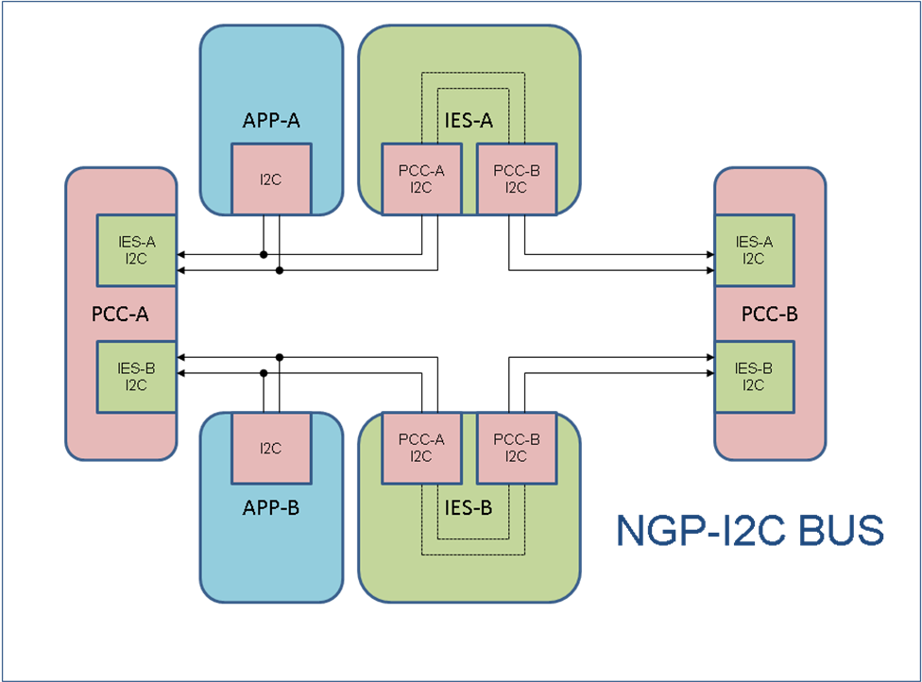

Power Supply
PCC board has to supply 6.5V to the IES board. IES board needs 3.3V; this supply voltage shall be derived from 6.5V on IES board. It’s preferred to use low cost switching regulators render higher efficiency (more prominent for high current rails). Linear regulator shall be used for lower current rails.

Debug/ Diagnostic
    - Status LEDs
IES board shall have sufficient diagnostic LEDs (including, 5V, 3.3V supply LEDs and LINK/ACTIVE LEDs on all the ports of ESCs, etc) to help during development phase.

    - Test Points
The board layout shall have test points coverage. i.e., critical signals on the board shall have test points on the board. These test points for the signals shall not be through-hole test points. These would be for ICT use in future.

ESD Protection
H/W design shall have adequate protection for the devices against ESD. Any signals which are likely to have human contact shall have the ESD protection.

Specific Requirements

Functional Requirements
    - It should implement EtherCAT protocol for communication between different boards( APPs and IOPs)

Schematic
    - Schematic file name should be 18-xxxxxx-rev-X.sch

Layout
    - File name should be 17-xxxxxx-xxx_revX.sch

Environmental Specification
    - For all IC’s and PCB components temperature rating shall be -40°C to +85°C.
    - 0 to 60°C Operating range
    - Storage temperature shall be -40°C to +85°C.
    - Humidity shall be 5 to 95% , non-condensing

Not in Scope
- User manual, tutorial or any other user documentation
- Certification, environmental, ATEX testing, EMI/EMC testing

Deliverables
Mindteck shall deliver the following hardware deliverables as per the project plan for CCC review and acceptance…

- Hardware Requirements Specifications document
- Hardware Design Document
- IES Card schematics design files
- Board Layout files & Gerber files
- IES Card Bill of Materials
- Tested prototypes
- Test reports

Testing Requirement
- Mindteck shall prepare the detailed test reports and presented to CCC for review and approval
- CCC shall conduct acceptance testing on receipt of the PCB assemblies as per agreed schedule

Appendix

Frame Processing Unit:
The frame processing order of EtherCAT Slave Controllers depends on the number of ports
Number of Ports | Frame processing order
1 | 0→EtherCAT Processing Unit→0
2 | 0→EtherCAT Processing Unit→1 / 1→0
3 | 0→EtherCAT Processing Unit→1 / 1→2 / 2→0 (log. ports 0,1, and 2)

The direction through an ESC including the EtherCAT Processing Unit is called “processing” direction, other directions without passing the EtherCAT Processing Unit are called “forwarding” direction. Ports which are not implemented behave similar to closed ports; the frame is forwarded to the next port. Figure below shows the frame processing in general:

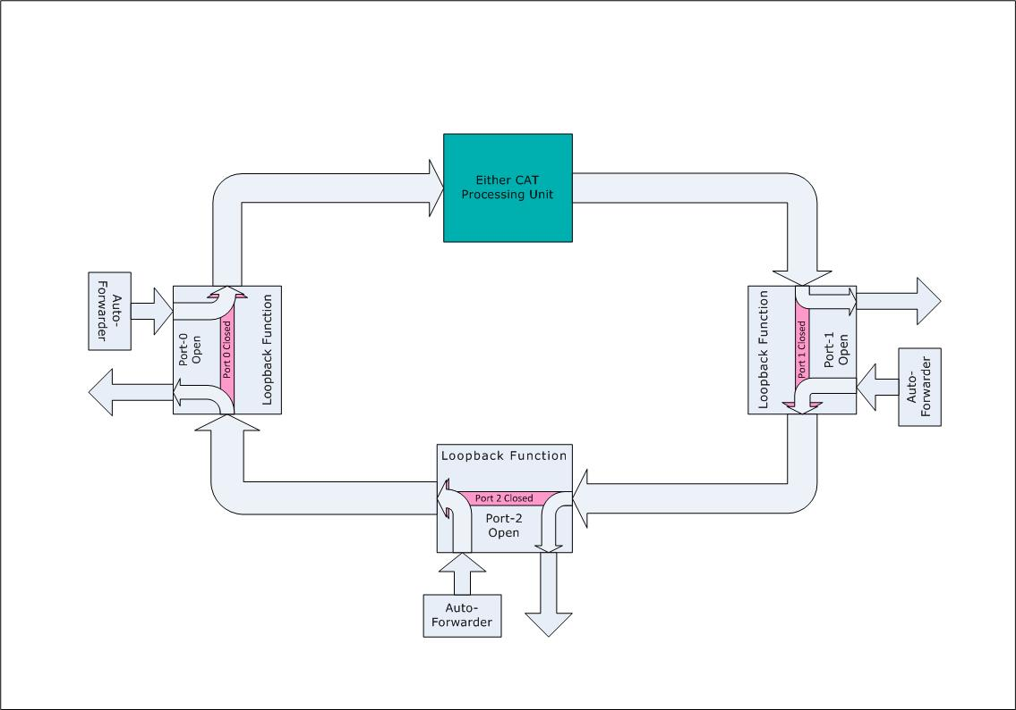

If the ports are ports 0, 1, and 2, a frame received at port 0 goes via the Auto-Forwarder and the loop back function to the EtherCAT Processing Unit which processes it. Then, the frame is sent to port 1. If port 1 is closed, the frame is forwarded by the loop back function to port 2. If port 1 is open, the frame is sent out at port 1. When the frame comes back into port 1, it is handled by the Auto-Forwarder and sent to port 2. Again, if port 2 is closed, the frame is forwarded to port 0, otherwise, it is sent out at port 2.When the frame comes back into port 2, it is handled by the Auto-Forwarder and then sent to the loop back function of port 0. Then it is handled by the loop back function and sent out at port 0 – back to the master.

